
The Synthetic Customer
2026-09-23 · Growth Marketing & Branding · CAROUSEL (8 slides)
Recommended: Several distinct, verified Gallup numbers (the generational gap, the disclosure exception, the synthetic person redline, the ubiquity stat) need sequential setup to land the real mechanism: it is not AI touching the ad that shoppers reject, it is AI impersonating the customer. A single static flip cannot carry that nuance without losing credibility.

The Anchor
Subject: Bentley University and Gallup, 2026 Business in Society Survey (AI in advertising)
Real fact: Gallup Panel survey of 3,270 U.S. adults, May 4 to 11, 2026: 66% of 18 to 29 year olds view AI use in advertising negatively versus 38% of those 45 to 59. 75% accept AI for brainstorming or early drafts once that use is disclosed, and 53% accept AI generating the finished ad text, images, or video, yet 62% say it is unacceptable for a business to use AI to create a person or voice in an ad, rising to 73% among 18 to 29 year olds, the single highest rejection number in the study. Separately, 79% of Americans say they saw an ad in the past 30 days that looked like it was made using AI. Published August 19, 2026.
Time peg: news (published August 19, 2026)
Source 1: https://news.gallup.com/poll/713222/americans-aren-sold-businesses-using-advertising.aspx

The Big Idea
DTC brands racing to replace real customer testimonials with cheap synthetic avatars in UGC style ads are optimizing for the exact AI use case shoppers, especially Gen Z, reject hardest: a fake person standing in for a real one.

Audience Takeaway
Use AI to draft, test, and iterate ad creative fast, Gallup's own data says that is broadly fine once disclosed. Do not use it to replace the actual customer inside a testimonial style ad. That is the one line this data says not to cross, and Gen Z, the segment DTC brands need most, is the group most ready to punish it.

Headline (the only text on the hero image)
Hook trigger: APPARENT NONSENSE
EN: The *customer* in your ad never existed.
ES: El *cliente* de tu anuncio nunca existió.
PT: O *cliente* do seu anúncio nunca existiu.
Open loop (EN): Gallup asked 3,270 shoppers what they think of the swap. Gen Z answered loudest ->
Open loop (ES): Gallup le preguntó a 3.270 personas qué piensan del cambio. La Gen Z respondió más fuerte que nadie ->
Open loop (PT): A Gallup perguntou a 3.270 pessoas o que acham dessa troca. A Geração Z respondeu mais alto que todo mundo ->
Eyebrow: The synthetic swap | El cambio sintético | A troca sintética
Headline color: #D50057 magenta (default) (off-brand allowed; chosen to stop the scroll)

Carousel Slides
Slide | EN | ES | PT
1 | The customer in your ad never existed. | El cliente de tu anuncio nunca existió. | O cliente do seu anúncio nunca existiu.
2 | 79% of Americans already spotted an ad they suspected was made by AI. | El 79% de los estadounidenses ya vio un anuncio que sospechó hecho con IA. | 79% dos americanos já viram um anúncio que desconfiaram ser feito por IA.
3  [62%] | Say a fake person or voice in an ad is unacceptable. Among shoppers under 30, that jumps to 73%, the highest rejection in the whole study. | Dice que una persona falsa en un anuncio es inaceptable. Entre los menores de 30, sube al 73%, el rechazo más alto de todo el estudio. | Diz que uma pessoa falsa no anúncio é inaceitável. Entre os menores de 30 anos, o número sobe para 73%, a rejeição mais alta de todo o estudo.
4  [66%] | Of shoppers 18 to 29 reject AI ads outright. Only 38% of those 45 to 59 feel the same. | De los compradores de 18 a 29 años rechaza los anuncios con IA. Solo el 38% de quienes tienen entre 45 y 59 años piensa igual. | Dos compradores de 18 a 29 anos rejeita anúncios com IA. Só 38% de quem tem entre 45 e 59 anos pensa o mesmo.
5 | 75% are fine with AI drafting the ad, as long as that use is disclosed. | Al 75% no le molesta que la IA redacte el anuncio, siempre que se avise. | 75% não se incomodam com a IA rascunhando o anúncio, desde que isso seja avisado.
6 | The cheapest ad format in DTC right now runs on a fake customer. | El formato de anuncio más barato del DTC hoy corre sobre un cliente falso. | O formato de anúncio mais barato do DTC hoje roda em cima de um cliente falso.
7 | The 75% who accept AI writing the ad stop the moment AI performs as the customer. | El 75% que tolera que la IA escriba el anuncio deja de tolerarlo en el momento en que la IA actúa como el cliente. | Os 75% que toleram a IA escrever o anúncio param de tolerar no momento em que a IA atua como cliente.
8 | Save this. Send it to whoever runs your ad account. | Guarda esto. Envíaselo a quien maneja tu cuenta de anuncios. | Salva isso. Manda pra quem cuida da sua conta de anúncios.

Caption (EN)
See Caption - The Synthetic Customer.md (Step 3) for the final, shipped caption. This field is a rough placeholder only.

Caption (ES)
Ver Caption - The Synthetic Customer.md (Paso 3) para la leyenda final.

Caption (PT)
Ver Caption - The Synthetic Customer.md (Etapa 3) para a legenda final.

Images (sourced from the web)
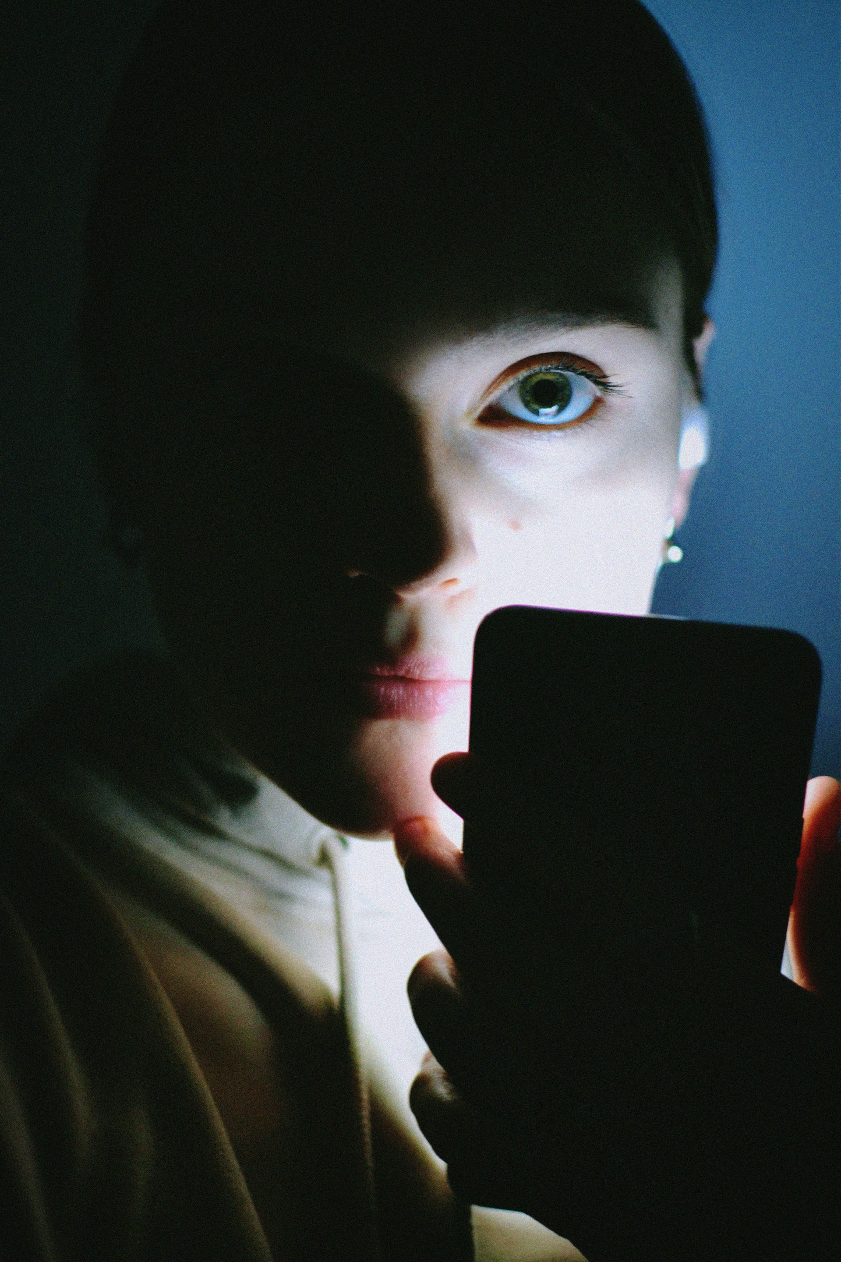
Hero (slide 1, hook): https://images.pexels.com/photos/12304661/pexels-photo-12304661.jpeg
Source: https://www.pexels.com/photo/12304661/ Author: Darya Grey_Owl (Pexels) License: Pexels License, free for commercial use
QA: Gate 0 pass (1920x2880, verified, clean, unique). Subject 8 (declared metaphor for an abstract hook claim) · five-posts 7 · charge 10 · currency 9 · legibility 9 · set distinction 10.
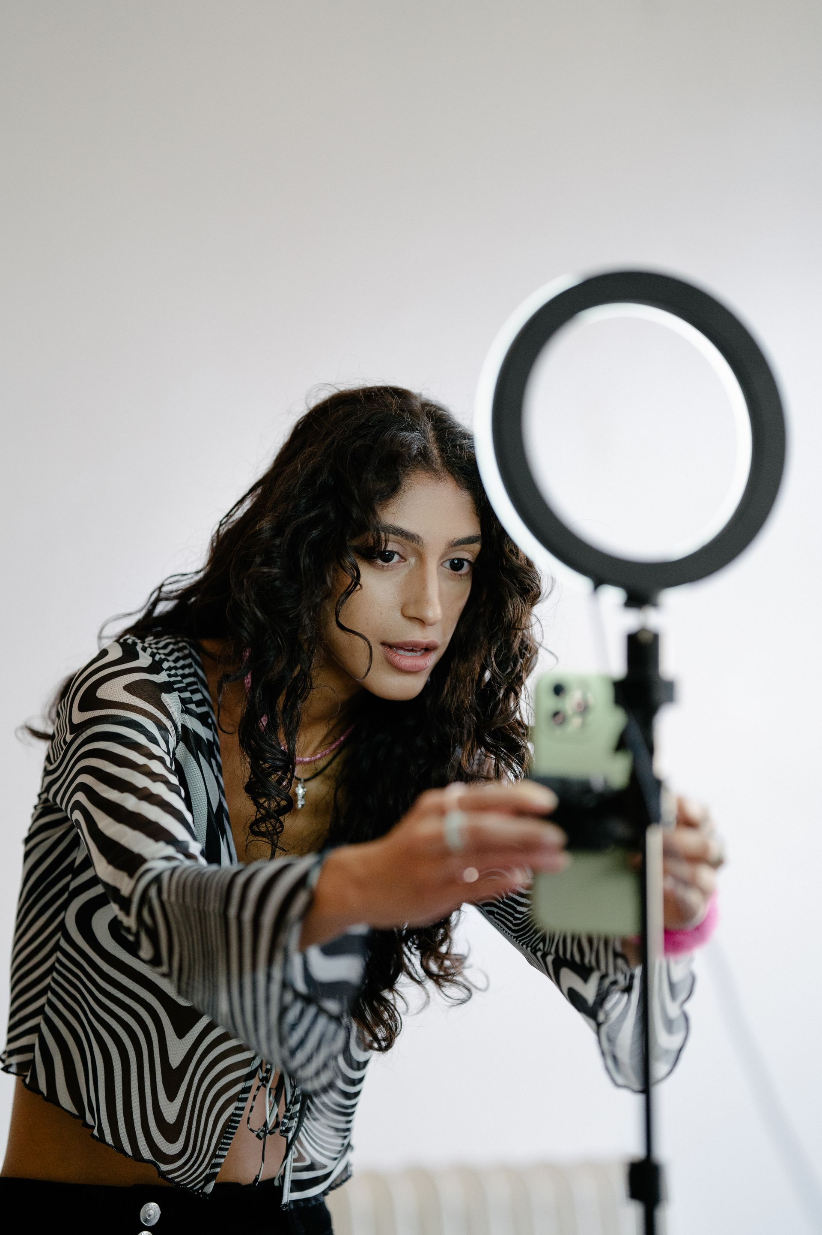
Slide 2 bg: https://images.pexels.com/photos/13929353/pexels-photo-13929353.jpeg
Source: https://www.pexels.com/photo/13929353/ Author: Mizunokozuki (Pexels) License: Pexels License, free for commercial use
QA: Gate 0 pass (1920x2880). Subject 8 · five-posts 7 · charge 8 · currency 9 · legibility 8 · set distinction 9.
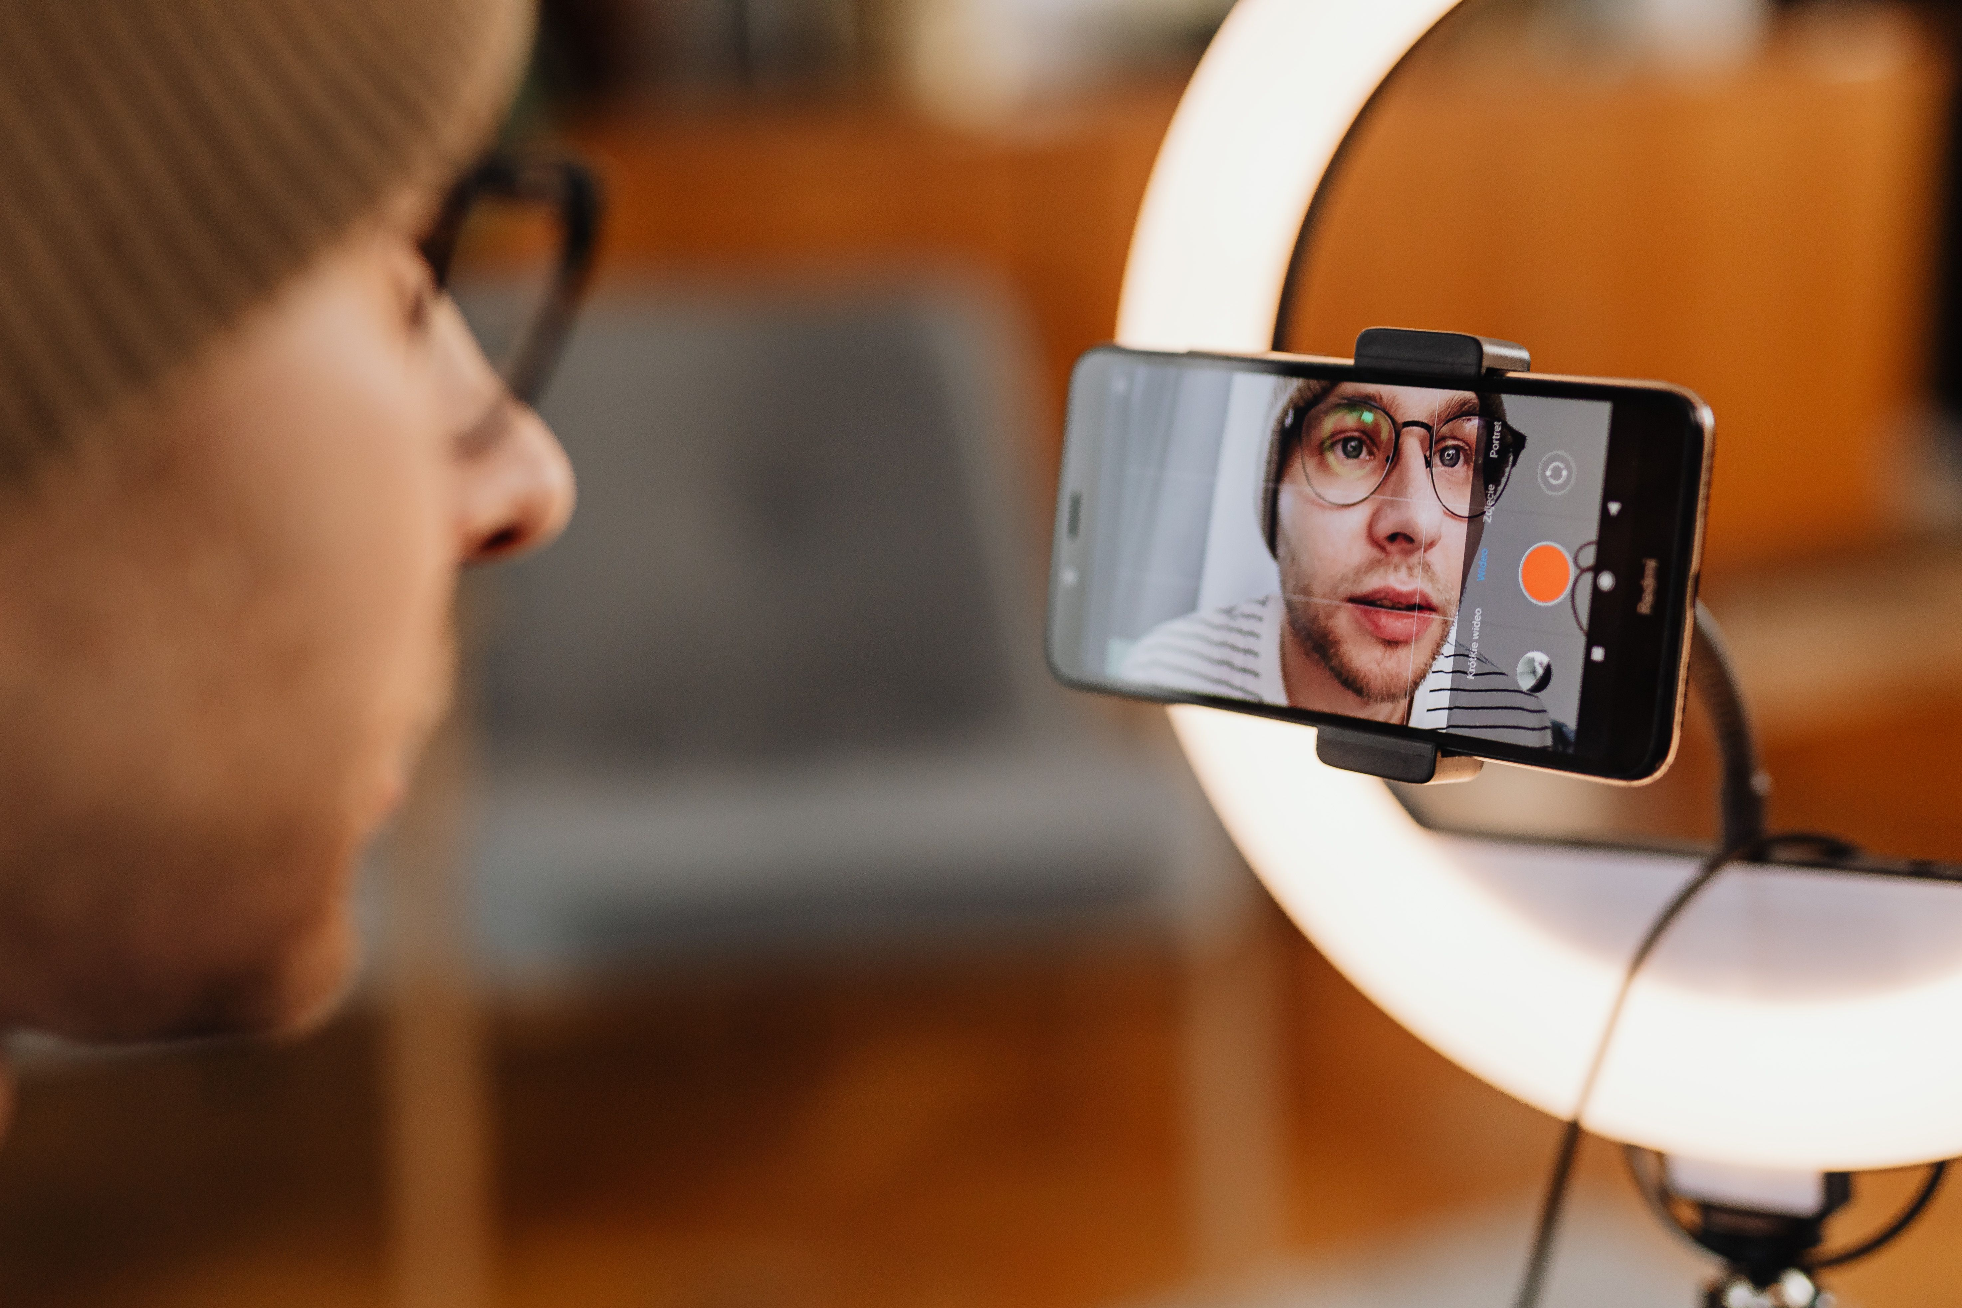
Slide 3 bg: https://images.pexels.com/photos/6333673/pexels-photo-6333673.jpeg
Source: https://www.pexels.com/photo/6333673/ Author: Karola G (Pexels) License: Pexels License, free for commercial use
QA: Gate 0 pass (5895x3930). Subject 8 · five-posts 7 · charge 8 · currency 9 · legibility 8 · set distinction 9.

Slide 4 bg: https://images.pexels.com/photos/7984973/pexels-photo-7984973.jpeg
Source: https://www.pexels.com/photo/7984973/ Author: Shkrabaanthony (Pexels) License: Pexels License, free for commercial use
QA: Gate 0 pass (1920x2880). Subject 9 · five-posts 7 · charge 9 · currency 9 · legibility 8 · set distinction 9.
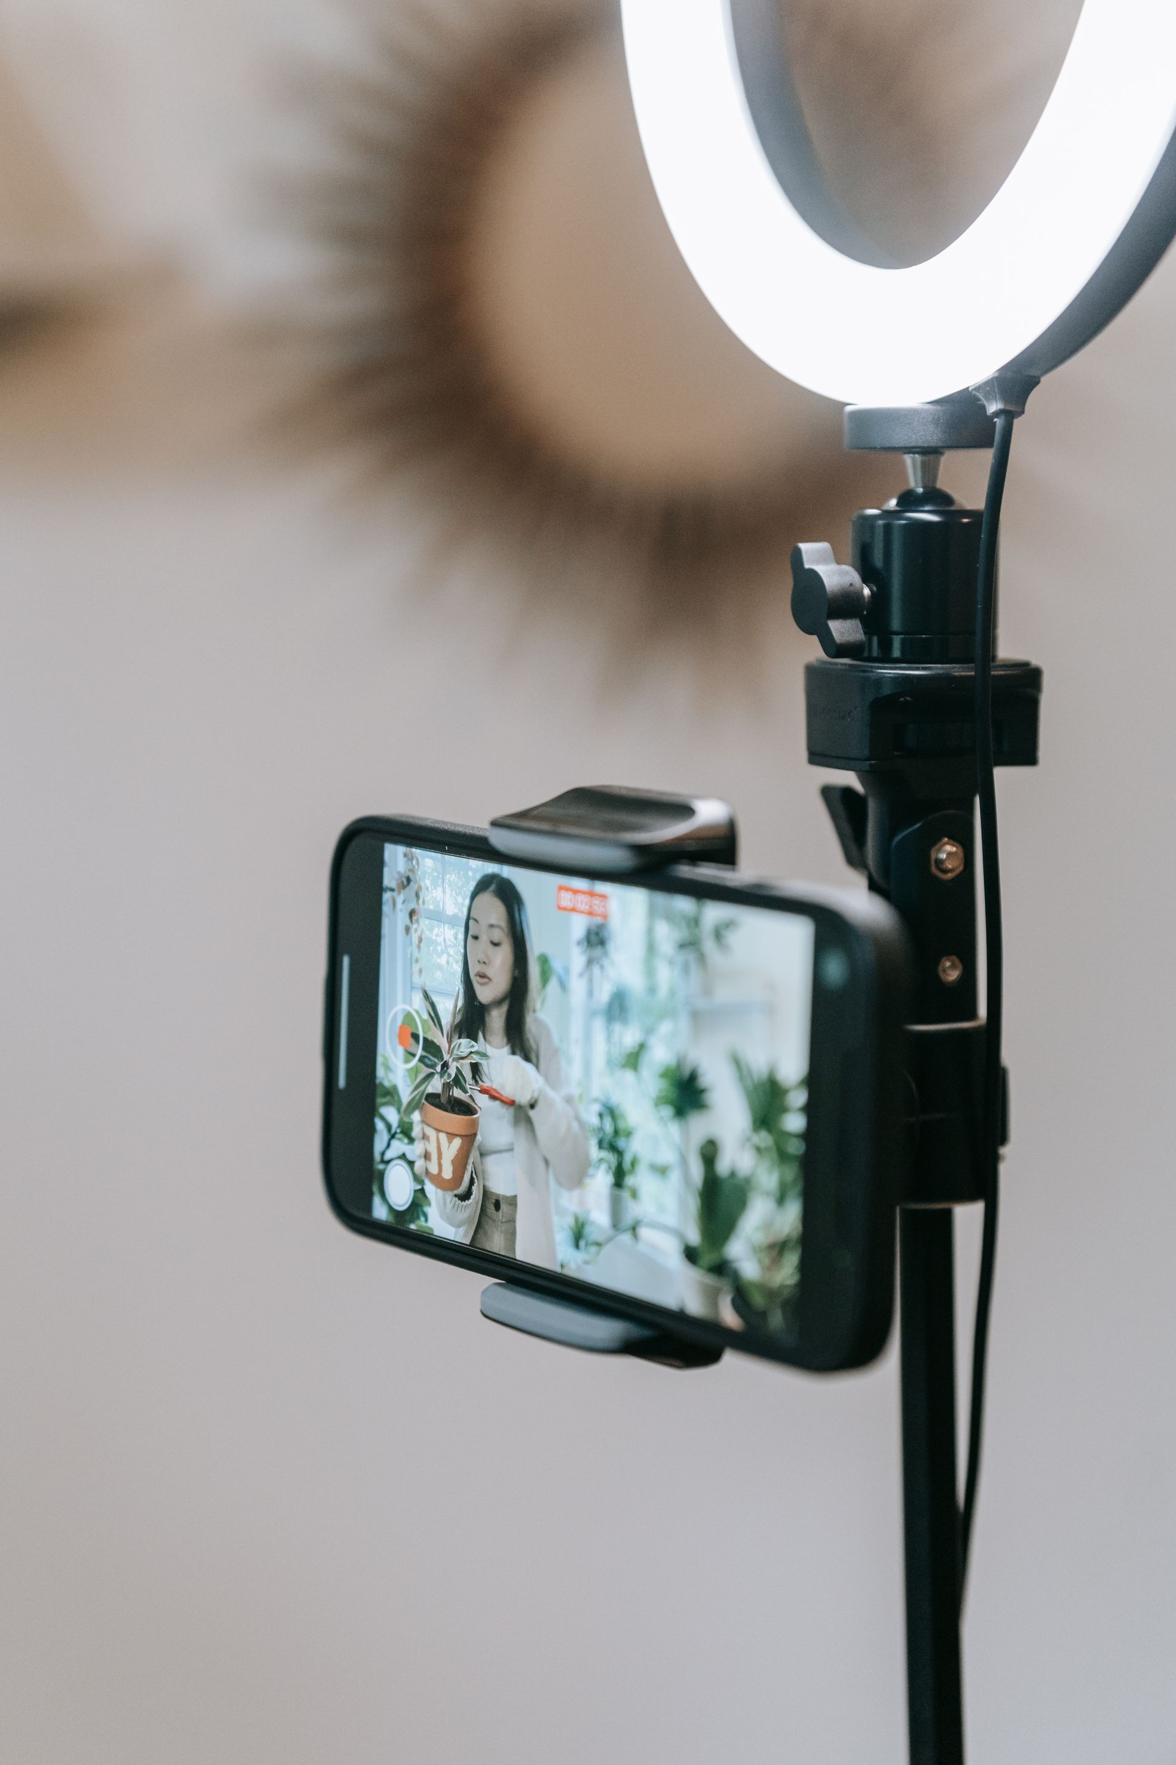
Slide 5 bg: https://images.pexels.com/photos/9413701/pexels-photo-9413701.jpeg
Source: https://www.pexels.com/photo/9413701/ Author: Sasha Kim (Pexels) License: Pexels License, free for commercial use
QA: Gate 0 pass (1920x2880). Subject 8 · five-posts 6 · charge 7 · currency 9 · legibility 8 · set distinction 8.
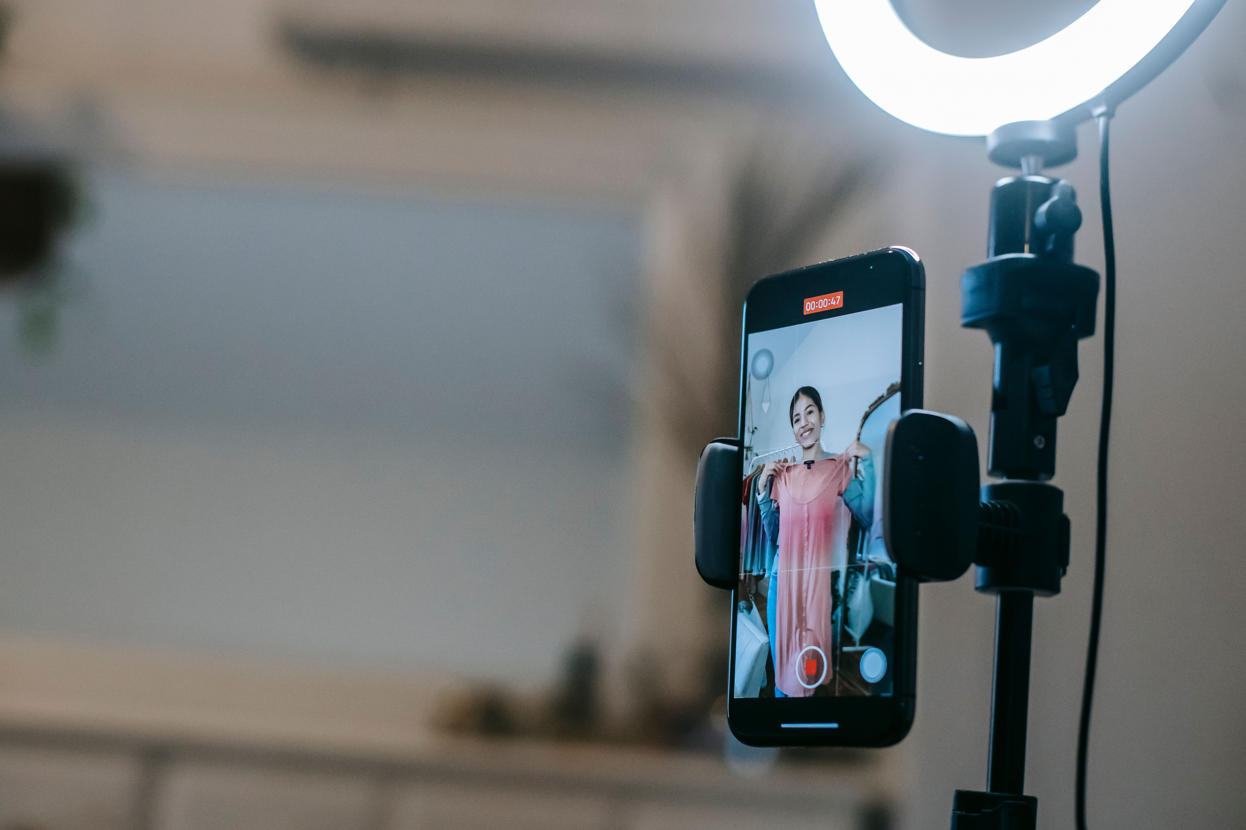
Slide 6 bg: https://images.pexels.com/photos/6347621/pexels-photo-6347621.jpeg
Source: https://www.pexels.com/photo/6347621/ Author: Liza Summer (Pexels) License: Pexels License, free for commercial use
QA: Gate 0 pass (5686x3791). Subject 10 (literal, not metaphor) · five-posts 5 · charge 7 · currency 9 · legibility 8 · set distinction 8.
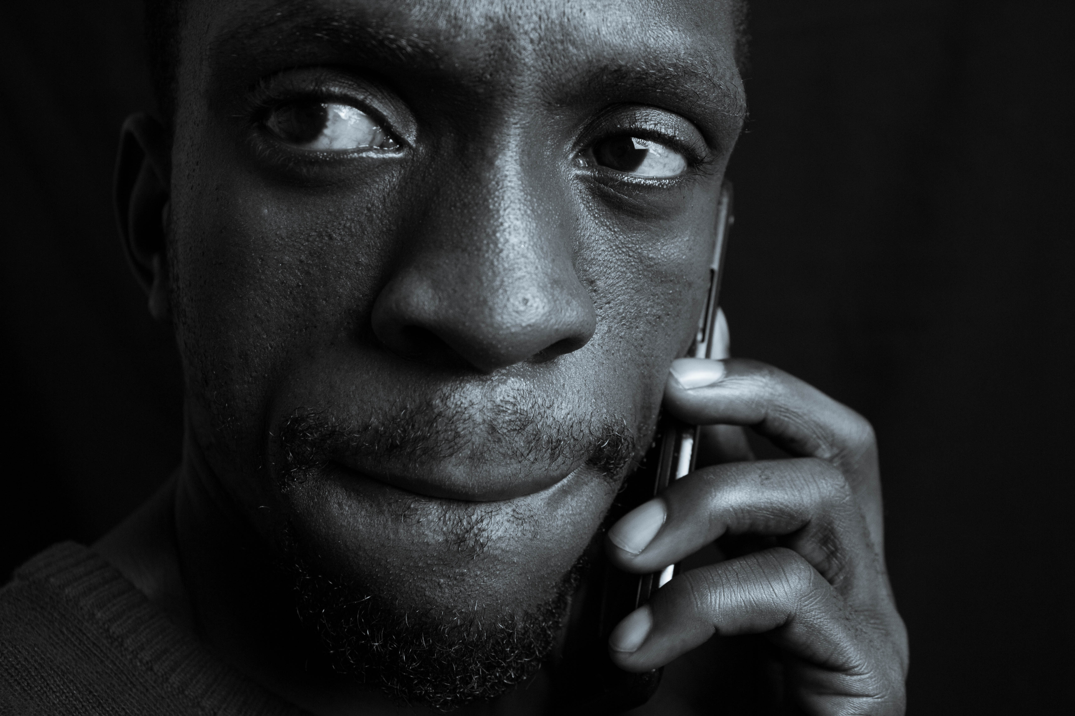
Slide 7 bg: https://images.pexels.com/photos/27404707/pexels-photo-27404707.png
Source: https://www.pexels.com/photo/27404707/ Author: Jose Maior (Pexels) License: Pexels License, free for commercial use
QA: Gate 0 pass (5184x3456). Subject 7 (declared metaphor for the pivot) · five-posts 7 · charge 9 · currency 8 (deliberate black and white rhythm break) · legibility 9 · set distinction 10.
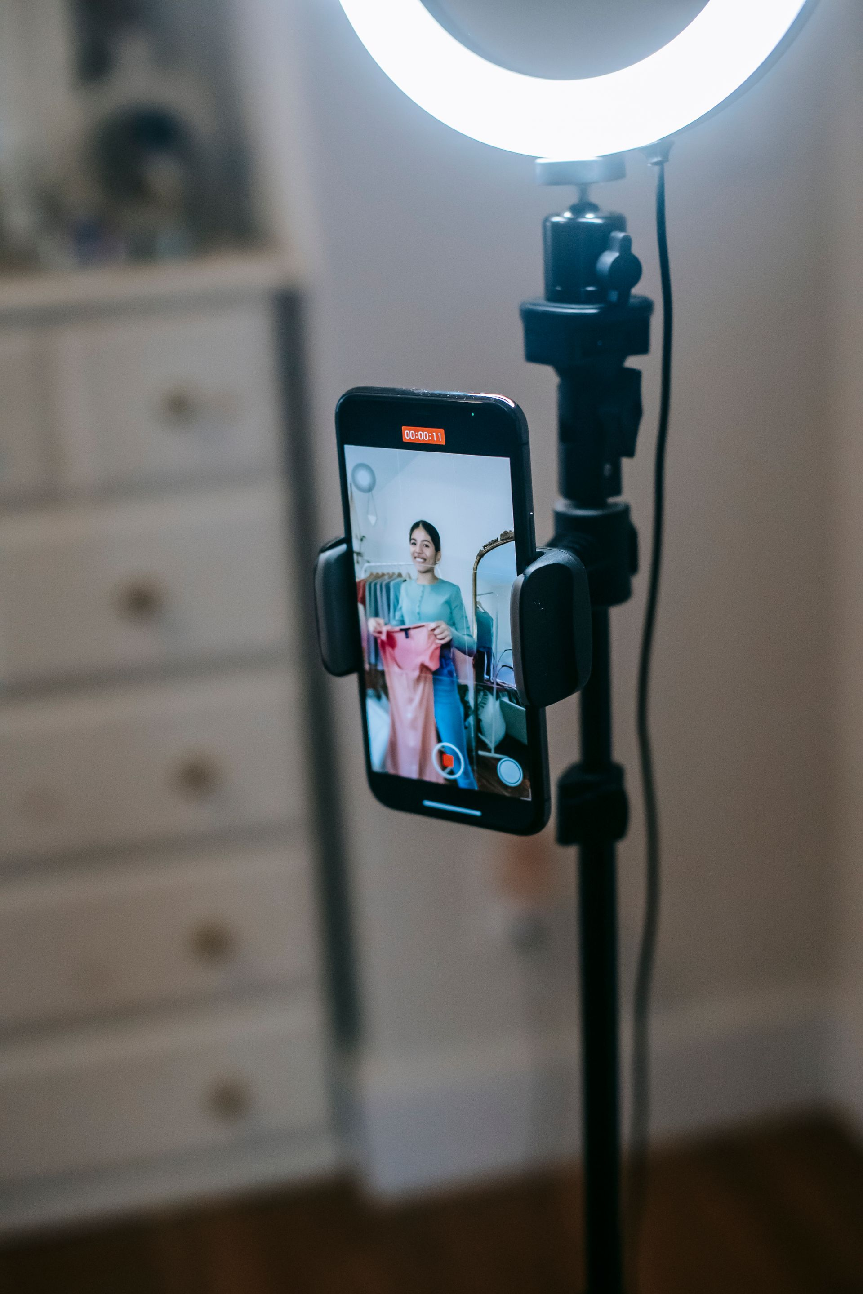
Slide 8 bg (CTA): https://images.pexels.com/photos/6347629/pexels-photo-6347629.jpeg
Source: https://www.pexels.com/photo/6347629/ Author: Liza Summer (Pexels) License: Pexels License, free for commercial use
QA: Gate 0 pass (1920x2880). Subject 9 (bookends the hook/slide 6 production theme) · five-posts 6 · charge 7 · currency 9 · legibility 8 · set distinction 8.

Visual Direction (for the design step)
Hero image: An extreme close up, half a face lit only by an unseen phone glow, one eye luminous against total shadow, a dark phone silhouette in the foreground. Evokes the hook's own ambiguity: is this even a real person.
Alt image queries: uncanny valley digital face close up | AI avatar spokesperson ad screen | deepfake face glitch portrait editorial
Color mood: teal accent energy (Growth Marketing pillar), real photo colour, no navy wash
Symbol corner: top-right
Logo (CTA slide): white logo on dark bg (CTA slide 8's background is treated dark)

Rights / Sensitivity
All eight photos are Pexels stock (Pexels License, free for commercial use, credited above). None depict a named public figure; all are anonymous private individuals used illustratively to represent shoppers and content creators in general, not implying any of them personally appears in or endorses synthetic advertising. None of the original @manofmany reference post's artwork was used or referenced visually anywhere in this brief or the rendered art; every image here was sourced fresh from Pexels specifically for this Rarity decode.
Next step: run rarity-ig-designer on this brief to build the EN, ES, and PT art with rarity-ig-designer.

